Task 1:

Create table

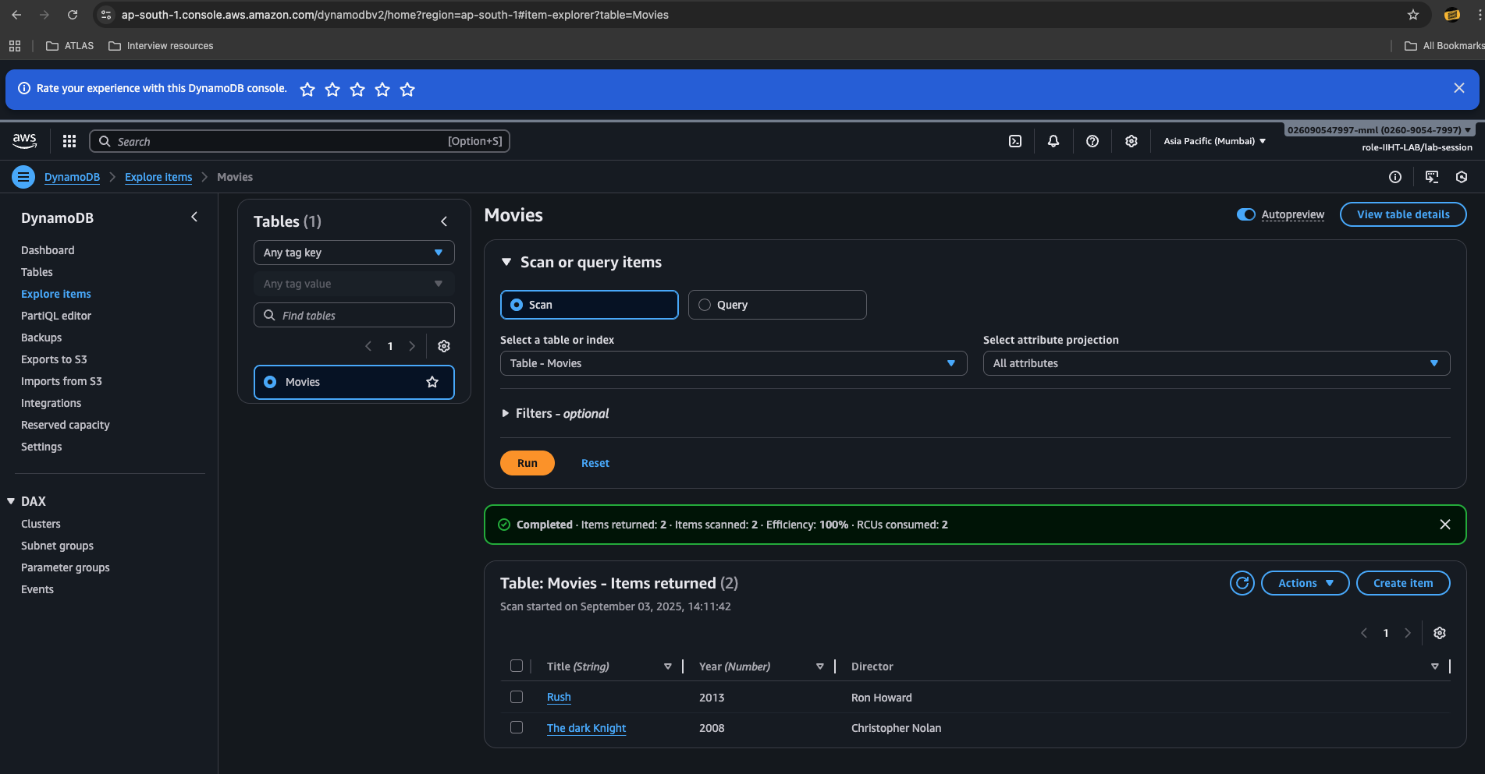

Read



Update:

Updated the year for the movie Rush
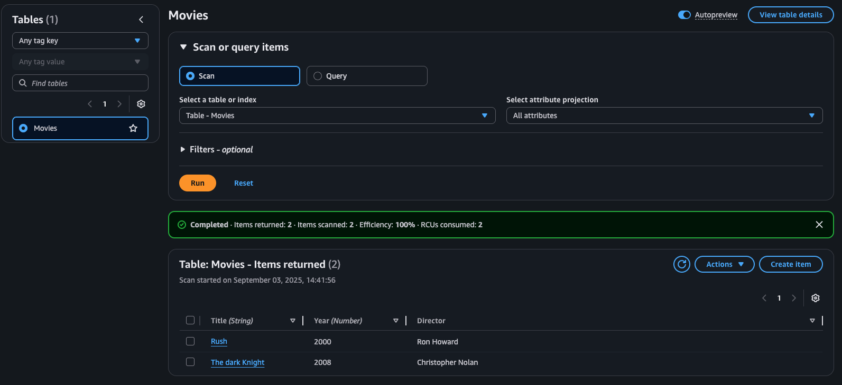
Delete:

Deleted the item movie rush

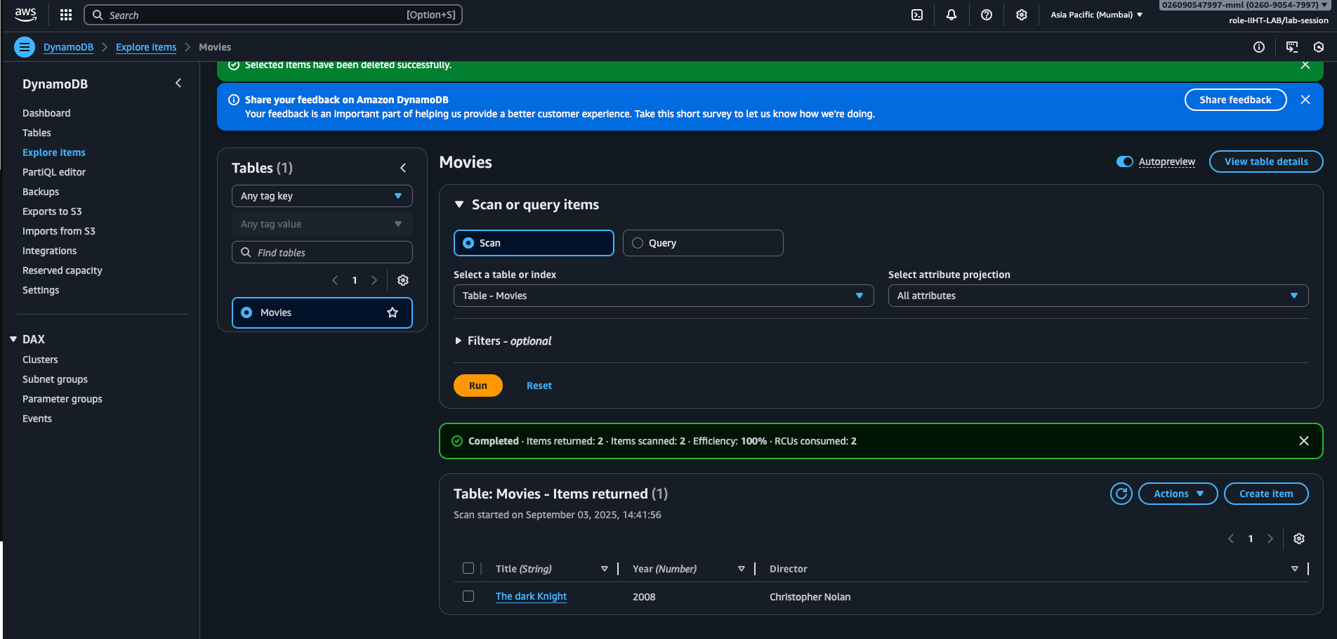

Script:

Creating a table

aws dynamodb create-table --table-name Employee --attribute-definitions AttributeName=ID,AttributeType=N AttributeName=EmpName,AttributeType=S --key-schema AttributeName=ID,KeyType=HASH AttributeName=EmpName,KeyType=RANGE --provisioned-throughput ReadCapacityUnits=5,WriteCapacityUnits=5

configuring AWS CLI
install aws cli - aws cli
configure aws cli
aws configure
aws access key
secret key
region and output format

IAM permissions:

IAM user or role

CreateTable
PutItems
Getitems
Query
UpdateItems
DeleteItems
DeleteTable
---------------------------------------------------------------
Add custom IAM policy

aws iam create policy \
--policy-name
DynamoDBManagementPolicy \
--policy-document '{"Version" : "2025-05-20",
"Statement" :
[ {"Effect": "Allow", "Action" :
["dynamodb: CreateTable",
"dynamodb: Query", .......],
"Resource": "*" } ] }'

the above policy lets give to a role/user

aws iam attach-user-policy --policy-arn arn:aws:iam:: DynamoDBManagementPolicy
--user-name emp(here give the username for whom your want to attach the above policy)

create table
insert data
crud operAtions

---- GUI , CLI, SDK...

insert into table

aws dynamodb put-item --table-name Employee --item '{"ID": {"N": "1001"},
"EmpName": {"S": "Yeswanth"} }'

aws dynamodb put-item --table-name Employee --item '{"ID": {"N": "1001"},
"EmpName": {"S": "Robert"} }'
.....

Query:

aws dynamodb query --table-name Employee
--key-condition-expression "ID = :ID"
--expression-attribute-values '{":ID":{"N":"1001"}}'

Update:

aws dynamodb update-item --table-name Employee
--key '{"ID": {"N": "1001"} , "EmpName": {"S": "Yeswanth"} }'
--update-expression "set info = :info"
--expression-attribute-values '{":info": {"S": "TY"}}'

Delete :

aws dynamodb delete-item --table-name Employee
--key '{"ID": {"N": "1001"}, "EmpName":{"S": "Prasunamba"} }'

